THE HAVERFORD SCHOOL PARENTS’ ASSOCIATION
F&E COMMITTEE
BUDGET-MAKING GUIDELINES

The purpose of a budget is to express your plan for your event in financial terms.

- You have been provided an Event Summary Overview and Event Summary Report from the previous year. The Event Summary Overview will give you an understanding of how to prepare and execute your event. The Event Summary Report will give you an understanding of how your event was handled the previous year and give you specifics on the income and expenses that were incurred from the previous year.

- You have also been provided a Budget Comparison spreadsheet for your event. This document details the financial aspects of your event from the previous year(s).

- Please collect the necessary estimates for all the expenses you think you will incur this year for your event. Using the Budget Comparison spreadsheet provided - input the estimated amounts in the appropriate categories on the spreadsheet.

- Remember to include those expenses donated by parents in BOTH the income and expense sections - donated items will go under In Kind Donations in the income section and then in the appropriate expense section so that they zero out.

- You will be required to attend your F&E Board meeting(s). Please bring copies of your Budget Comparison spreadsheet - completely filled out. You will need to present your budget to the committee and discuss your financial plans for your event. The F&E Board will need to approve your budget so that your expenses can be properly processed.

- A hard copy of your Event’s Budget Comparison spreadsheet - has been provided to you. If you would like an electronic copy, please let the Treasurer know.

- Please use the Tax Exempt Certificate when you purchase items for events. Use the Tax Exemption Certificate that has been included in your packet or you may find it on the Haverford School website - https://www.haverford.org/parents/hspa/forms-downloads.

- TAX NOTE: SALES TAX IS NOT REIMBURSABLE. If you have paid sales tax, it will be deducted from your reimbursement.
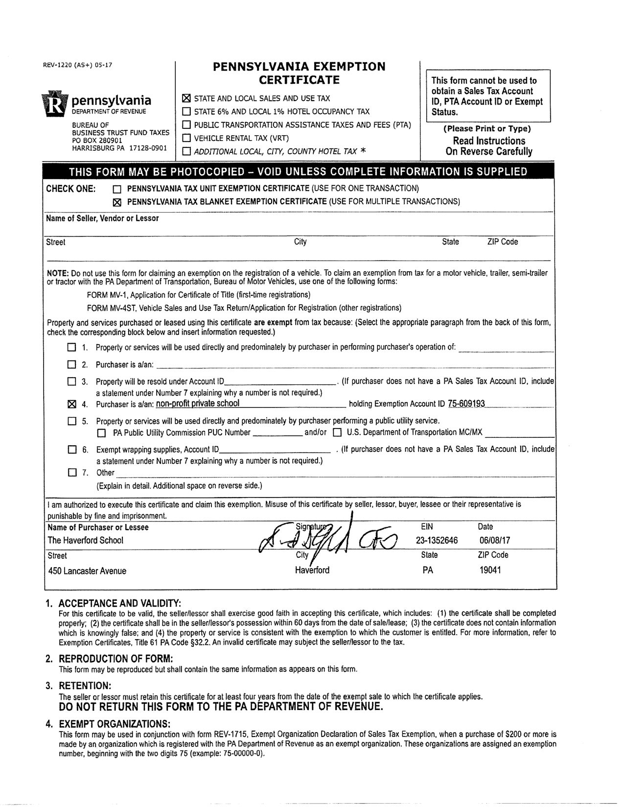
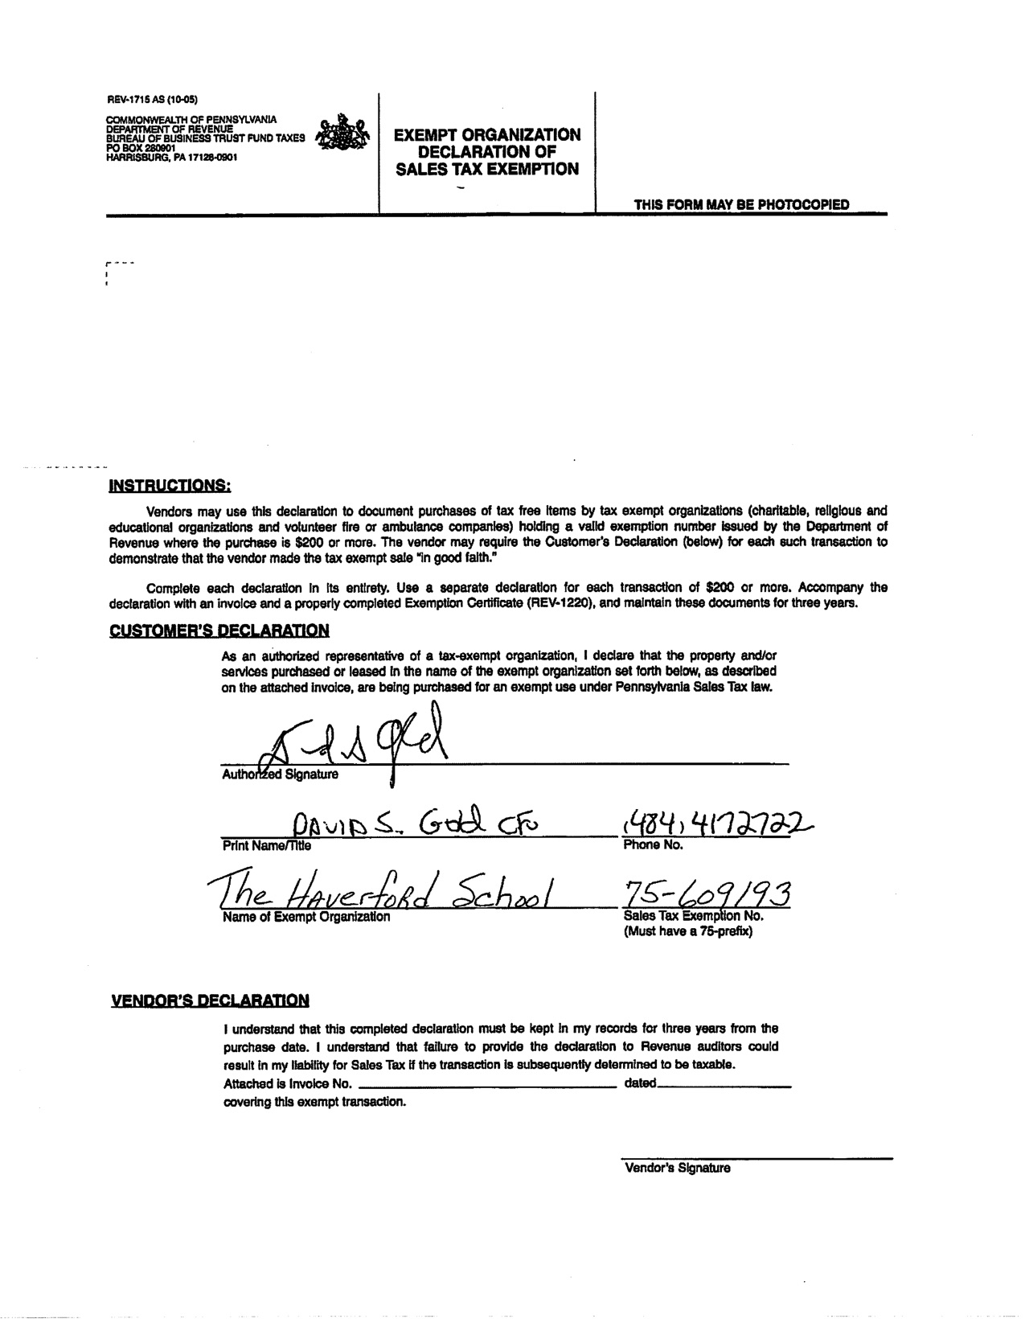

HAVERFORD SCHOOL PARENTS’ ASSOCIATION
EXPENSE VOUCHER

To be used for all expenses to be reimbursed. Please complete one form Per Person. All receipts MUST be included.

TAX NOTE: SALES TAX IS NOT REIMBURSABLE. If you have paid sales tax, it will be deducted from your reimbursement.

USE OUR PA SALES TAX EXEMPTION CERTIFICATE when making purchases on behalf of the HSPA.

This Reimbursement is for:

NAME:
ADDRESS:
CITY, STATE, ZIP:
PHONE:
EVENT/PROJECT:
DATE:

ITEMIZED EXPENSES

EXPENSE | AMOUNT
TOTAL:

Signature of Project Leader/Project Treasurer/Class Parent

X ___________________________________________________________________

HAVERFORD SCHOOL PARENTS’ ASSOCIATION
PETTY CASH DISBURSEMENT LOG

This form should be filled out and submitted to the HSPA Treasurer or the Director of Parent Programs by the end of the day of the event. Please list all disbursements made before, during and after the event that have been deducted from the petty cash that was provided for the event.

PROJECT:
DATE:
SUBMITTED BY:
SIGNATURE OF CHAIR:
PHONE:

Individual Reimbursed | Items Purchased | Vendor/Retailer | $ Amount

